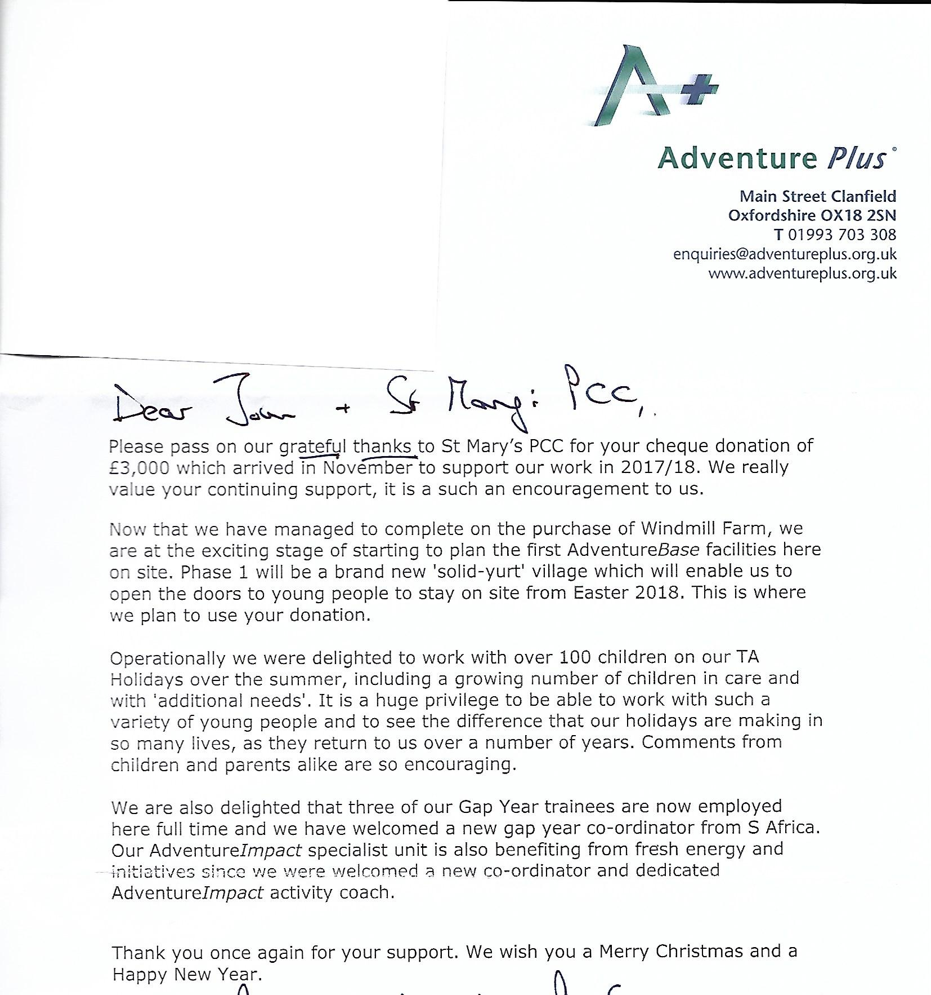
With Sincere thanks and Warm Christmas Greetings from all at Adventure Plus,
Jonathan Cox
Executive Director of Adventure Plus

