Baptism Enquiry
Your name
Spouse/partner’s name
Your child’s full name:
Your child’s date of birth:
Your address:
Your email address:
Phone number:
Best time to phone you:
Signed:
Date:
----------------------------------------------------------
FOR CHURCH USE ONLY
Date of visit
Type of service
Time and date

For those living outside Cholsey, Winterbrook or Moulsford:
Details of local vicar

Consent obtained

St Mary’s Cholsey, as part of the Church of
England, baptises people both as adults and as
children.
If you wish your child to be baptised (also called a
“Christening”) you as parents will be:
- thanking God for the gift of life,
- deciding to start your child on
the journey of faith,
- promising to do all you can to
help your child on that journey,
- asking for the Church’s support.
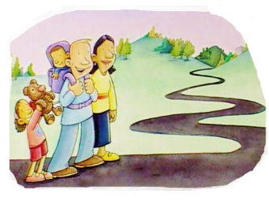
For your child,
baptism marks
the start of a
journey of faith,
following Christ
and becoming a
member of
the local and
worldwide
Christian family.
In baptism, we are thanking God for his gift of
life and publicly acknowledging his love for us.
We are also responding to God’s love, by
acknowledging that we need to turn away from a self-centred life and to make a new start with
God.
Making decisions and promises
When you bring your child for baptism, you will
be asked to declare publicly on behalf of your
child that you believe and trust in God and that
you will bring your child up to follow Jesus.
You will be asked to answer, on your child's
behalf, that you have decided to turn away from
everything which is evil or sinful and to turn
instead to following Christ.
Frequently asked questions
Can we have a private service of baptism?
Baptisms now take place in the church’s main
service. This is so that your child can be seen
to be joining the family of the Church and that
the local congregation can in turn welcome the
child into the family and also promise to
support and pray for you and your child.
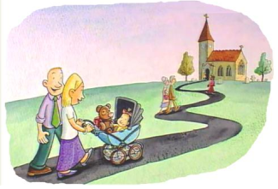
We therefore
set aside a
number of
Sundays in
the year,
when we can
welcome the
child into
God’s family
by baptism.
If you are particularly keen to have a private
service for family and friends, e,g, on a
Sunday afternoon, it may be more appropriate
for you to have a service of Thanksgiving
and Blessing (see next section).
I’m not a regular churchgoer: can I still
have my child baptised?
The Church believes that God’s love is
available to all, regardless of their background.
However, in the Baptism service you will be
making promises in public and before God to
encourage your child to be an active part of the
church, by your teaching and by your example.
If you decide you are not able to make such a
commitment, we can talk you about other
options: For example, you may prefer to
have a Thanksgiving and Blessing service,
where you can thank God for the wonderful
gift of your baby and we ask for God’s
blessing on both your child and you as parents.
(continued overleaf)

This is a lovely service in its own right, but still
leaves open the option of baptism should you
decide at a later date, that this is what you would
like.
You may also wish to find out more about the
Christian faith and what joining the Church
involves before you make a decision about
baptism. Again, you can ask the Vicar for
guidance about this.
Who should I choose to be a godparent?
Godparents make the same promises as parents
on behalf of the child being baptized.
Godparents must also be willing to promise to
pray and support the child and to help the parents
to bring up the child in the Christian faith.
It is an important and responsible role.
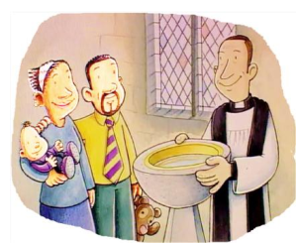
For the baptism
itself, parents and
godparents will be
asked to gather at
the front of the
church and then
around the font.
(The font is a large basin containing the water for baptism.)
Godparents can be family members or friends.
However, it is important that you choose people
who will take an interest in your child's spiritual
welfare and who will pray for you and your child.
They must also have been baptized themselves.
What does the Baptism service cost?
The Baptism service is free.
What happens after the baptism?
Baptism marks a new start for your child, as a
member of the worldwide Christian community.
In turn, the Church welcomes you and your child
and promises to help and support you in bringing
the child up in the Christian faith.
Children are
particularly
welcome at
our main
morning
services,
where we have
special groups and activities for them.
What is the right age for baptism?
Baptism can happen at any age.
What matters is that those concerned are happy to
make the promises that are a vital part of Baptism. Teenagers and adults may also be baptised. This is usually celebrated at a Confirmation service by the Bishop.
You can only be baptised once, but there are
different ways of renewing your commitment
publicly as an adult – your Vicar will be able to advise about this.
What do I do now?
Please contact our church office either by
emailing mail@cholseychurch.plus.com
or phoning 01491 651812 (and leave a message
if no one answers)
or by completing the slip at the front of this leaflet and returning it to
Church Office, Church Road, Cholsey, Oxon OX10 9PP
(next to the Laurence Hall)
Material adapted from: Your Child's Baptism in the Church
of England – Church House Publishing
Illustrations: Simon Smith © Church Pastoral Aid Society
