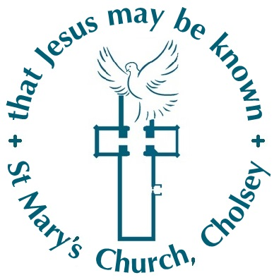
Family Worker at St Mary’s Church, Cholsey
Role Description and Person Specification - January 2022

St Mary’s Church, Cholsey is a lively, welcoming village church with a desire to ‘make Jesus known’. We are seeking someone who has a passion for Christ and for children and families to work with us so that Jesus may be known amongst more families within our village.
Purpose of the post:
In these changing times, we are seeking a Families Worker who can help us explore new ways of engaging with families; someone who can help us develop a vision and a plan to evolve and grow our existing activities and relationships.
Job Specification:
The role is likely to include the following responsibilities. However, a refined role specification would be developed in conjunction with the Family Worker, following appointment, based on further discussion of the appointee’s thoughts, ideas and vision for the role.
- Build relationships with families in the village of Cholsey so that Jesus may be known.
- Build on and further develop existing relationships with the local schools including Cholsey Primary School. This will include leading the ‘Open the Book’ initiative at Cholsey School.
- Lead our thriving toddler group ‘Little Fishes’ in Cholsey, working with the existing team of volunteers.
- Work with the existing team to support the work of our Cholsey Sunday morning kid’s club and Forest Church.
- Develop further ways to grow relationships with and disciple families (working alongside church members) e.g. parenting courses, special services, social events, holiday clubs
- Promote the work with families to the Parochial Church Councils (PCCs) of Cholsey and the wider church community.
St John the Baptist, Moulsford is a small village church within our benefice. It is situated just 1.5 miles from Cholsey, along the banks of the Thames, and is a very caring community. From time to time, the Family Worker may be asked to support the work of St John the Baptist church amongst families and children. This work would be undertaken during the paid hours of the role or as additional paid hours.
Person specification:
The postholder will be able to demonstrate:
- Excellent inter-personal skills and the ability to work as part of a team, encourage the involvement of others and build teams of volunteers
- Experience of successfully working with children and families in a church situation (whether in a paid or unpaid capacity)
- A good understanding of family life in the present context
- Skills in relating to people of varied backgrounds and positions of religious faith
- The ability to use existing networks or create new ones in order to facilitate peer-to-peer support between families
- Ability to understand and be able to follow policies and procedures, especially with regard to safeguarding and confidentiality
- Creative, innovative and has the ability to use strategic thinking in order to develop a vision and long-term plans
- A vibrant Christian faith, and a commitment to prayer and to personal development and growth
- Self-motivation, good personal organisation and flexibility
- Ability to use social media and other communication methods for networking with parents and promoting the Christian faith and the work of the Church
- An Occupational Requirement exists for the post-holder to be a practising Christian in accordance with the Equality Act 2010.
The appointment is subject to an enhanced DBS Disclosure. Information related to safeguarding within our church can be found at https://www.stmaryscholsey.org/aboutus/safeguarding/
What we offer to the postholder
As our current Vicar retires in February, the Family Worker will meet regularly with a lay member of the congregation as line manager and for supervision. This line manager has extensive experience in working with children and families, safeguarding, mental health and well-being. In addition, Oxford Diocese provide advice and networking opportunities with other Family Workers through their Discipleship Enablers and Children’s and Family Ministry Specialist.
We are committed to assisting the postholder to develop their abilities through appropriate training in, for example, bereavement, mental health awareness, safeguarding, lone working.
Paid hours: 20 per week; hours of work to be flexible, including evening and weekend working as required; at least one full day off to be taken each week.
Pro-rated salary: £12-13,500 yearly depending on experience and qualifications
The Employer is the Parochial Church Council (PCC) of St Mary’s, Cholsey.

